**Warhammer Design Document**

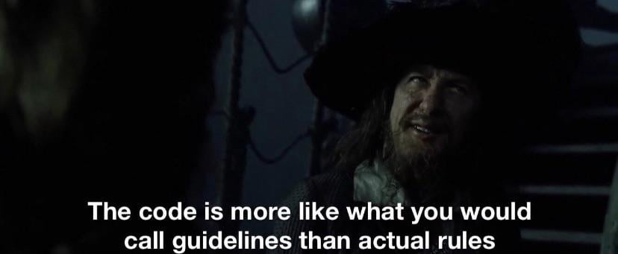

Howdy, thank you for your interest in modding for Warhammer Universalis, this document is intended to be a centralized documentation for the mod. It is outdated in sections and not elaborated in others, if you have any questions please contact me.

Over-Arching Design Philosophy:

Warhammer as a setting is about two things, ‘rule of cool’ and ‘your dudes’. It’s not about the lore as written but the stories that you develop from playing the game. It’s about the staunch line of spears that held out against blocks of chosen for 5 turns, 4 longer then mathematically they should. It’s about when your uber powerful Chaos lord gets sniped turn 1 by (un)lucky cannon rolls. In this vein this mod seeks to encapsulate that and give in breath in EU4.

This mod will allow players to finally see their stories and the loose plot threads from lore unfold: For Example: what if the Forces of Good finally decisively won against the forces of chaos, (I’d say vice versa but that’s just the end-times), the dwarves reforge the karaz ankor etc. etc.

Tldr; If its cool and gives a unique gameplay style/effect not really seen elsewhere then it probably fits.

This mod generally aims to remain close to the EU4 core gameplay loop as possible. No massive changes: races and tags can subvert this, however. Like the Warriors of Chaos; if EU4 is about the premise of a Westphalian nation state, what would a Chaotic Warband look like given that context?

Racial Mechanics:

* Give buffs/debuffs per race.

Old World Human:

Normal EU4 mechanics

The Empire:

Impassable Rivers were not fun.

Bretonnia:

Estalia:

Tilea:

Border Princes:

Vampire Count:

Skaven:  
 Skavenblight will be an entirely separate map offset from the rest of the world in a corner somewhere, the skaven clans will fight for the provinces there. The connections will be

1. Zombie Marsh,
2. Lustria,
3. Naggaroth
4. Darklands
5. Southlands
6. Middle Mountains
7. Central World Edge Mountains
8. Karak-Eight Peaks
9. Cathay

Magic System:

Enabled if

NOT

Dwarf

Khornate

Mages_banned

2 ways players can interact

Uses government mechanics to easily show spells and winds of magic available 2 Buttons

* Cast National Spells
* Improve Spell casting capabilities!

**Winds of Magic Gain**

Winds of magic are gained at a slightly random pace:  
Each region will have a random amount of winds of magic gain for a set period of time

Every 1-5 years master event will trigger

Then for every country in each region (determined by capital area in which region) will get an event that will tell them the amount about how the winds of magic flow in the region.

Winds of Magic determines amount of Spells you can cast

Each lore has 3 levels. Apprentice, Hero, Lord